DAILY ONLINE ACTIVITIES SUMMARY
Date: |  | 5/06/2020
Name of the Faculty |  | Ankitha Shetty
No. of Students Allotted for monitoring |  |  |  | 16
Progress |  |  |  | Good
Whether collected report from all the allotted students |  |  |  | 12 students are updating daily  2 students are involved in online activity.  2 students are not uploading anything.
Online Test Summary
Subject | Operation Research
Semester | 6 |  |  | Duration | 1 hour 15min
No. of students Taken |  |  | 107 | Passing % | 96
Certification Course Summary
Course |  | - Webinar on Digital Knowledge  - Webinar on Brain Computer Interface
Certificate Provider |  | - ICT Academy Skycampus  - Hosted by NIT-K (STEP) & Pantech |  | Duration |  | 2 hour
Coding Challenges
Problem Statement: C Program to Generate Prime Numbers in an Interval
Status: 37
Uploaded the report in Github |  |  |  | Yes
If yes Repository name |  |  |  | https://github.com/ankishetty91/ankitha-daily-report
Uploaded the report in slack |  |  |  | Yes

Certification Course Summary

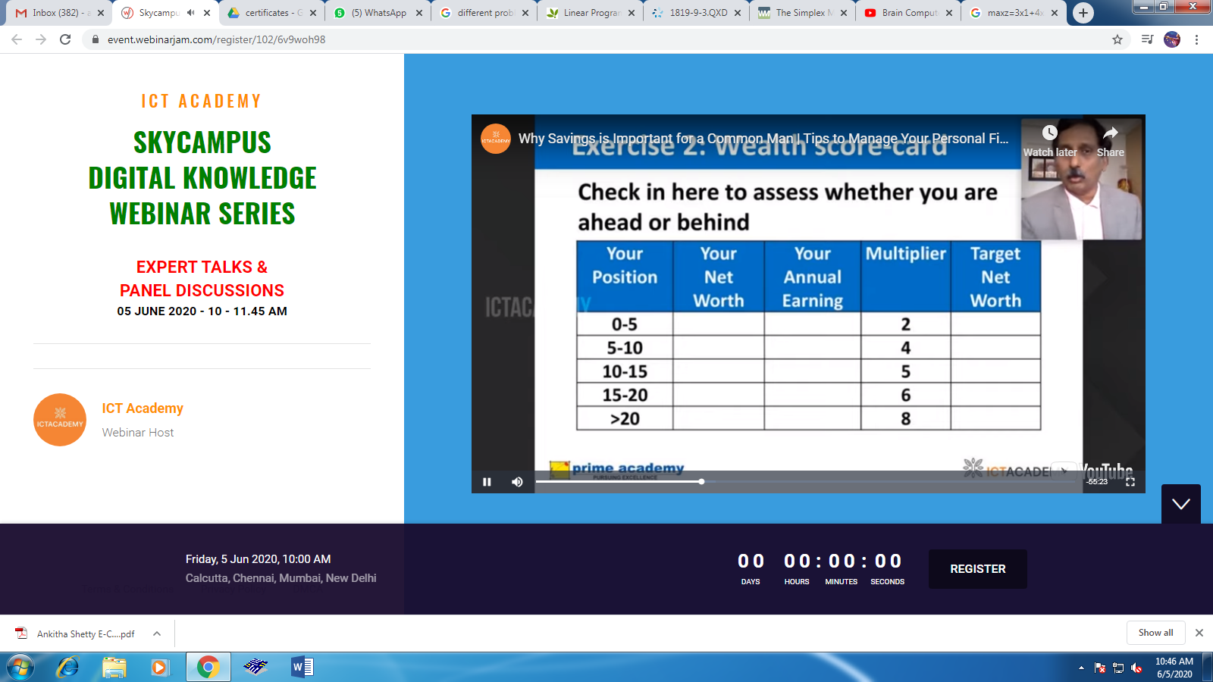
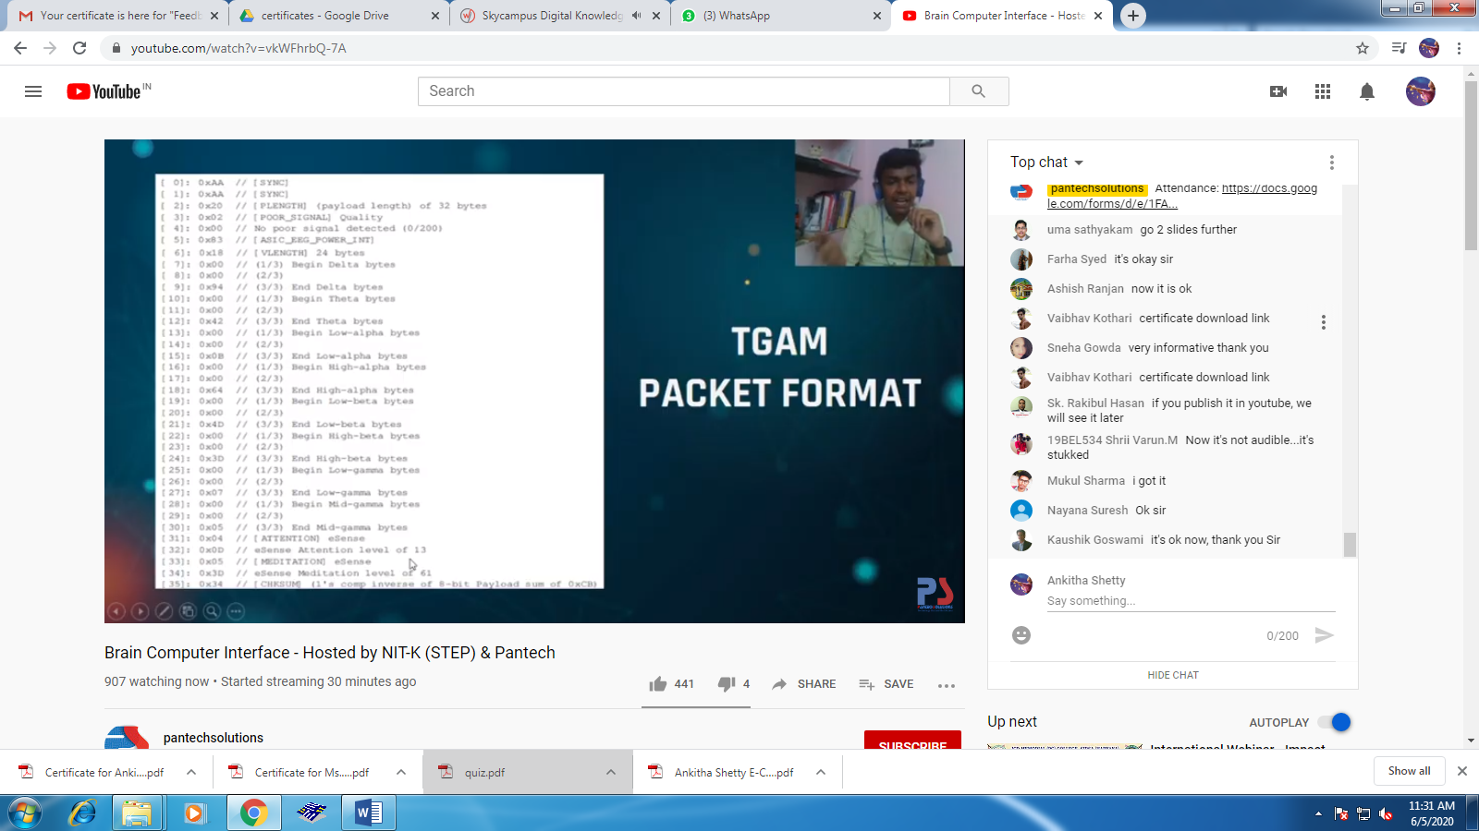

Students Report:

